Scratch Movement Quiz Name____________________________

For each of the following, draw an X where the cat would be after each of the following commands:

1.
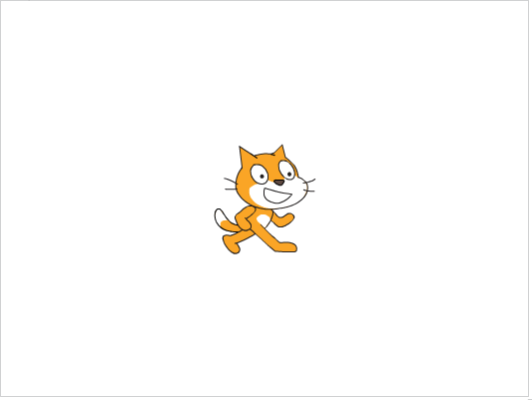
2. 

3. 


4. 


5. 

6. 


